

**Savitribai Phule Pune University**

**T. Y. B. B. A. (C.A.) Semester - V**

**(CBCS 2019 Pattern)**

**PRaCTICAL SLIP**

**Name : Lalit devidas patil**

**College Name: SINHGAD COLLEGE OF ARTS & COMMERCE WARJE PUNE-58**

|  |  |  |  |  |
| --- | --- | --- | --- | --- |
|  |  |  |  |  |

**Roll no : 106 Division:b seat NO:**

**Academic year : 2024-25**

***Certificate***

**This is to certify that**

**Mr. PATIL LALIT DEVIDAS**

**Seat Number_____of T.Y.BBA(CA) Sem - V has Successfully completed Laboratory course**

**(Core Java) in the Year . He has scored mark out of 10 (For Lab Book).**

**--------------------------------**

**Subject Teacher H.O.D./Coordinator**

**Internal Examiner External Examiner**

**Slip 1**

**A) Write a ‘java’ program to display characters from ‘A’ to ‘Z’.**

public class Slip_1A {

    public static void main(String[] args) {

        for (char letter = 'A'; letter <= 'Z'; letter++) {

            System.out.print(letter + " ");

        } }}

**Output**

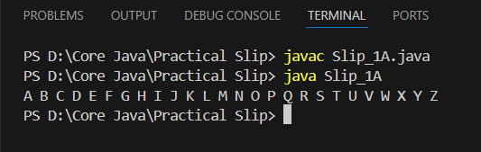

**B) Write a ‘java’ program to copy only non-numeric data from one file to another file.**

import java.io.*;

public class Slip_1B {

    public static void main(String[] args) {

        String sourceFile = "Source.txt";

        String destinationFile = "Destination.txt";

        try {

            FileReader reader = new FileReader(sourceFile);

            FileWriter writer = new FileWriter(destinationFile);

            int character;

            while ((character = reader.read()) != -1) {

                if (!Character.isDigit(character)) {

                    writer.write(character);

                }

            }

            reader.close();

            writer.close();

            System.out.println("Non-numeric data copied successfully!");

        } catch (IOException e) {

            System.out.println("An error occurred: " + e.getMessage());

        }

    }

}

**Source.txt**

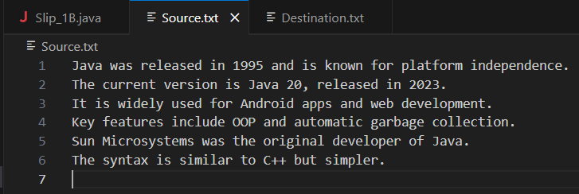

**Destination.txt**

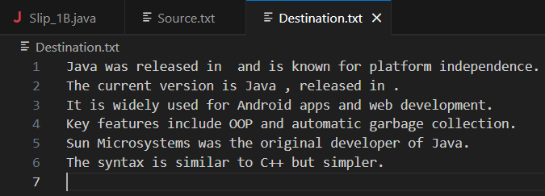

**Output**

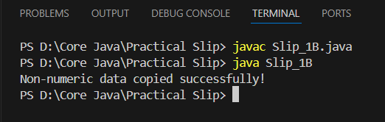

**Slip 2**

**A) Write a java program to display all the vowels from a given string.**

import java.util.Scanner;

public class Slip_2A {

        public static void main(String[] args) {

            Scanner scanner = new Scanner(System.in);

            System.out.print("Enter a string: ");

            String input = scanner.nextLine();

            input = input.toLowerCase();

            System.out.print("Vowels in the string are: ");

            for (int i = 0; i < input.length(); i++) {

                char ch = input.charAt(i);

                if (ch == 'a' || ch == 'e' || ch == 'i' || ch == 'o' || ch == 'u') {

                    System.out.print(ch + " ");

                }

            }

            scanner.close();

        }

    }

**Output**

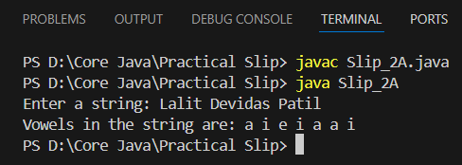

**B) Design a screen in Java to handle the Mouse Events such as MOUSE_MOVED and MOUSE_CLICK and display the position of the Mouse_Click in a TextField.**

import javax.swing.*;

import java.awt.*;

import java.awt.event.*;

public class Slip_2B extends JFrame implements MouseListener, MouseMotionListener {

    private JTextField textField;

    public Slip_2B() {

        setTitle("Mouse Event Demo");

        setSize(400, 300);

        setDefaultCloseOperation(JFrame.EXIT_ON_CLOSE);

        setLayout(new FlowLayout());

        textField = new JTextField(25);

        textField.setEditable(false);

        add(textField);

        addMouseListener(this);

        addMouseMotionListener(this);

        setVisible(true);

    }

    @Override

    public void mouseClicked(MouseEvent e) {

        textField.setText("Mouse Clicked at: (" + e.getX() + ", " + e.getY() + ")");

    }

    @Override

    public void mouseMoved(MouseEvent e) {

        textField.setText("Mouse Moved at: (" + e.getX() + ", " + e.getY() + ")");

    }

    @Override

    public void mousePressed(MouseEvent e) {}

    @Override

    public void mouseReleased(MouseEvent e) {}

    @Override

    public void mouseEntered(MouseEvent e) {}

    @Override

    public void mouseExited(MouseEvent e) {}

    @Override

    public void mouseDragged(MouseEvent e) {}

    public static void main(String[] args) {

        new Slip_2B();

    }

}

**Output**

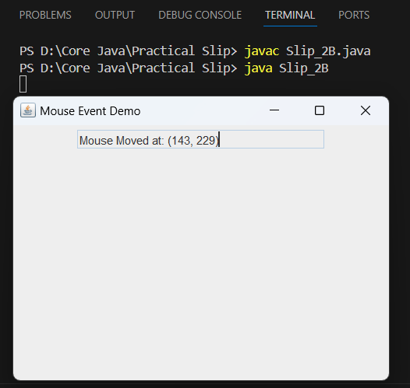

**Slip 3**

**A) Write a ‘java’ program to check whether given number is Armstrong or not. (Use static keyword)**

import java.util.Scanner;

public class Slip_3A {

    public static void main(String[] args) {

        Scanner scanner = new Scanner(System.in);

        System.out.print("Enter a number: ");

        int number = scanner.nextInt();

        if (isArmstrong(number)) {

            System.out.println(number + " is an Armstrong number.");

        } else {

            System.out.println(number + " is not an Armstrong number.");

        }

        scanner.close();

    }

    public static boolean isArmstrong(int num) {

        int originalNumber = num;

        int sum = 0;

        int length = String.valueOf(num).length();

        while (num != 0) {

            int digit = num % 10;

            sum += Math.pow(digit, length);

            num /= 10;

        }

        return sum == originalNumber;

    }}

**Output**

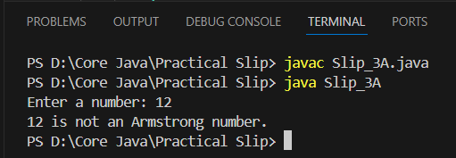

**B) Define an abstract class Shape with abstract methods area () and volume (). Derive abstract class Shape into two classes Cone and Cylinder. Write a java Program to calculate area and volume of Cone and Cylinder.(Use Super Keyword.).**

import java.util.Scanner;  
abstract class Shape{  
    int a,b;  
    Shape(int x, int y){  
        a = x;  
        b = y;  
    }  
    abstract double area();  
    abstract double volume();  
}  
class Cone extends Shape{  
    Cone(int x, int y){  
        super(x,y);  
    }  
    double area(){  
        return (a*b*3.14);  
    }  
    double volume(){  
        return (3.14*a*a*b);  
    }  
}  
class Cylinder extends Shape{  
    Cylinder(int x, int y){  
        super(x,y);  
    }  
    double area(){  
        return (2*3.14*a*b*3.14*a*b);  
    }  
    double volume(){  
        return (3.14*a*a*b);  
    }  
}  
   
class Slip3B{  
    public static void main(String args[]) throws Exception{  
        int r,h,s;  
        Scanner scan = new Scanner(System.in);  
        System.out.println("Enter Radius, Height and Side Values : ");  
        r = scan.nextInt();  
        h = scan.nextInt();  
        s = scan.nextInt();  
        Shape s1;  
        Cone c1 = new Cone(r,s);  
        s1=c1;  
            System.out.println("Area of Cone  is : " + s1.area());  
            System.out.println("Volume of Cone is : " +s1.volume());  
        Cylinder cy = new Cylinder(r,h);  
        s1 =cy;  
            System.out.println("Area of Cylinder  is : " + s1.area());  
            System.out.println("Area of Cylinder  is : " + s1.volume());  
    }  
}

**Output**

